11. Python Program to Solve the 8-Queen Problem

Aim
To write a Python program to solve the 8-Queen problem by placing 8 queens on a chessboard so that no two queens attack each other.

Algorithm
- Start the program.
- Create an 8 × 8 chessboard.
- Place one queen in each row.
- Check whether the queen conflicts with any previous queen.
- If safe, place the queen and move to the next row.
- If no safe position exists, backtrack.
- Display the solution.
- Stop the program.

Code

# 8-Queen Problem using Backtracking

N = 8 board = [-1] * N

def is_safe(row, col): for r in range(row): if board[r] == col:
return False if abs(board[r] - col) == abs(r - row):
return False return True

def solve(row): if row == N: return True for col in range(N): if is_safe(row, col): board[row] = col

if solve(row + 1): return True

board[row] = -1

return False

if solve(0): print("Solution:") for row in range(N): for col in range(N): if board[row] == col: print("Q", end=" ") else: print(".", end=" ") print() else: print("No solution")
OUTPUT
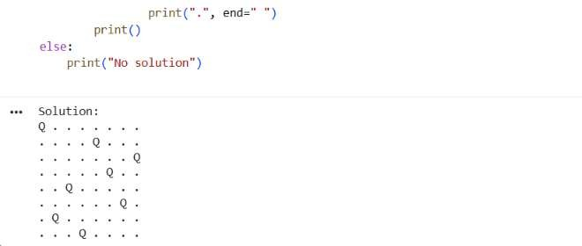
12. Python Program for the Water Jug Problem

Aim
To write a Python program to solve the Water Jug problem using the Breadth-First Search (BFS) algorithm.

Algorithm
- Start the program.
- Define two jugs with capacities of 4 litres and 3 litres.
- Set the target amount to 2 litres.
- Generate possible operations: fill, empty, and pour water.
- Use BFS to search for the target state.
- Display the steps to reach the target.
- Stop the program.

Code

# Water Jug Problem using BFS

from collections import deque

def water_jug(): capacity1 = 4 capacity2 = 3 target = 2 start = (0, 0) queue = deque([(start, [])]) visited = set()

while queue:
(a, b), path = queue.popleft()
if (a, b) in visited: continue visited.add((a, b))

new_path = path + [(a, b)]

if a == target or b == target:
return new_path

pour = min(a, capacity2 - b) states = [
(capacity1, b),
(a, capacity2),
(0, b),
(a, 0),
(a - pour, b + pour)
]

pour = min(b, capacity1 - a) states.append((a + pour, b - pour))

for state in states: if state not in visited: queue.append((state, new_path)) return None

solution = water_jug()

if solution:
print("Steps:") for step in solution:
print(step) else:
print("No solution found")
OUTPUT:

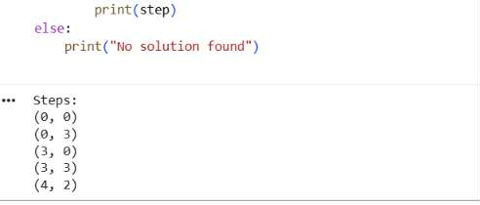

13. Python Program for the Crypt-Arithmetic Problem

Aim
To write a Python program to solve the crypt-arithmetic problem SEND + MORE = MONEY, where each letter represents a unique digit.

Algorithm
- Start the program.
- Assign different digits to the letters.
- Ensure that S and M are not zero.
- Check whether SEND + MORE = MONEY.
- Display the valid solution.
- Stop the program.

Code

# Crypt-Arithmetic Problem

from itertools import permutations

letters = "SENDMORY"

for digits in permutations(range(10), len(letters)):
d = dict(zip(letters, digits))

if d['S'] == 0 or d['M'] == 0:
continue

SEND = 1000*d['S'] + 100*d['E'] + 10*d['N'] + d['D']
MORE = 1000*d['M'] + 100*d['O'] + 10*d['R'] + d['E']
MONEY = (10000*d['M'] + 1000*d['O'] +
100*d['N'] + 10*d['E'] + d['Y'])

if SEND + MORE == MONEY: print("SEND =", SEND) print("MORE =", MORE) print("MONEY =", MONEY)
break

OUTPUT
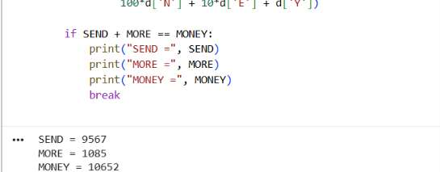

14. Python Program for the Missionaries and Cannibals Problem

Aim
To write a Python program to solve the Missionaries and Cannibals problem using the Breadth-First Search (BFS) algorithm.

Algorithm
- Start the program.
- Consider 3 missionaries and 3 cannibals on the left bank.
- Allow a boat to carry 1 or 2 people.
- Generate possible boat movements.
- Ensure cannibals never outnumber missionaries on either bank when missionaries are present.
- Use BFS to find a valid solution.
- Display the steps.
Stop the program.
# Missionaries and Cannibals using BFS

from collections import deque

def valid(m, c): if m < 0 or c < 0 or m > 3 or c > 3:
return False

# Missionaries must not be outnumbered if m > 0 and m < c:
return False

right_m = 3 - m right_c = 3 - c

if right_m > 0 and right_m < right_c:
return False

return True

def solve(): start = (3, 3, 0) # 0 = left, 1 = right goal = (0, 0, 1)

moves = [(1, 0), (2, 0), (0, 1),
(0, 2), (1, 1)]

queue = deque([(start, [start])]) visited = {start}

while queue: state, path = queue.popleft() m, c, boat = state

if (m, c) == (0, 0): return path

for dm, dc in moves:
8.
Code

if boat == 0:
new_state = (m-dm, c-dc, 1)
else:
new_state = (m+dm, c+dc, 0)

nm, nc, _ = new_state

if valid(nm, nc) and new_state not in visited: visited.add(new_state) queue.append((new_state, path + [new_state]))

return None

solution = solve()

if solution: for step, state in enumerate(solution):
m, c, boat = state print("Step", step, ": Left =", m, "M", c, "C", "| Right =", 3-m, "M", 3-c, "C", "| Boat =", "Left" if boat == 0 else "Right") else: print("No solution found")

OUTPUT:
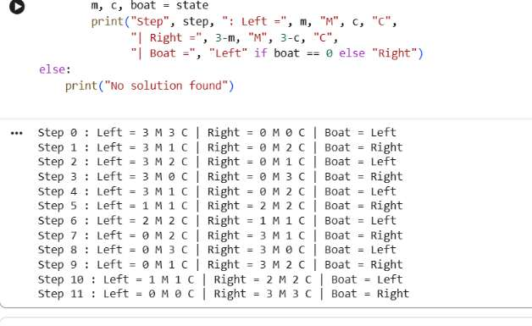
15. Python Program for the Vacuum Cleaner Problem

Aim
To write a Python program to simulate a vacuum cleaner that cleans dirty rooms using simple condition-based actions.

Algorithm
- Start the program.
- Define two rooms, A and B.
- Mark each room as clean or dirty.
- Check the current room.
- If it is dirty, clean it.
- Move to the next room and repeat.
- Display the final room status.
- Stop the program.

Code

# Vacuum Cleaner Problem

rooms = {
'A': 'Dirty',
'B': 'Dirty'
}

location = 'A'

while True:
print("Vacuum cleaner is in room", location)

if rooms[location] == 'Dirty': rooms[location] = 'Clean' print("Room", location, "cleaned")

if location == 'A': location = 'B' else: break

print("\nFinal Room Status:") for room, status in rooms.items(): print("Room", room, ":", status)
OUTPUT:

